Lab Task:
- Implement the following program on eclipse IDE and answer the following questions:
- How many threads are running?
- How many tasks are running?
- If more tasks are added than what will be the impact on number of threads?
- Explain the flow of program:
Output
1.
1 main thread
3 child threads
Total threads = 4
2.
Total Task = 3
3.
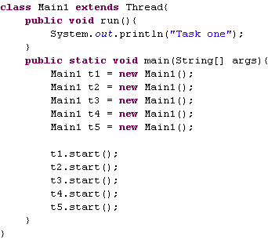
4.
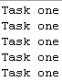

2.With the help of threading print two tables concurrently, print one table number of student roll number e.g. 2019-SE-092 and second number should be date of birth e.g. 05-April.

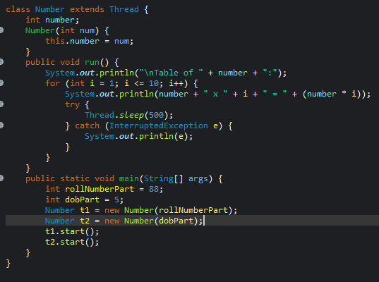
Output
